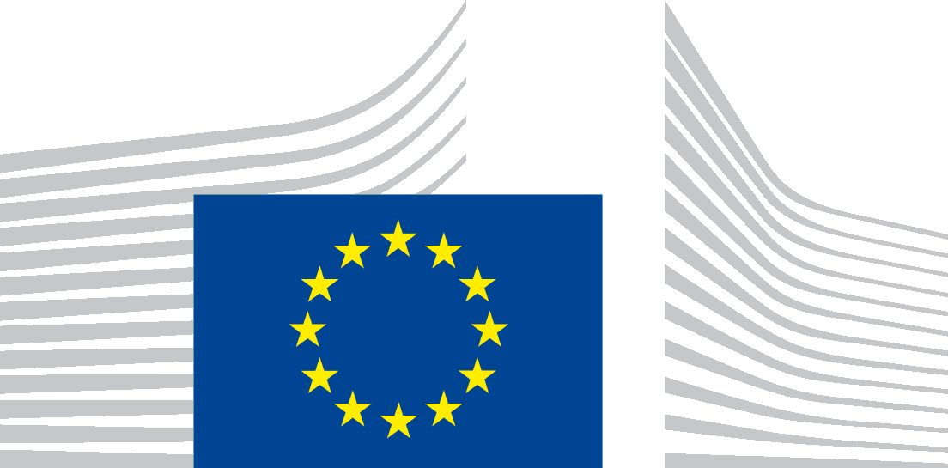 | EUROPEAN COMMISSION  Directorate-General Neighbourhood and Enlargement Negotiations

EU Press trip - 14-16 March 2016
List of participants

- Ms Siobhan Geets (Wiener Zeitung), Austria
- Ms Marijana Miljkovic (WirtschaftsBlatt), Austria
- Ms Mette Joergensen Rodgers (Information), Denmark
- Mr Samuel Kingsley (YLE radio), Finland
- Ms Tiia-Maria Taponen (Iltalehti), Finland
- Mr Richard Fuchs (Deutsche Welle), Germany
- Mr Pantelis Gonos (ERT, Greek radio television), Greece
- Ms Ivett Korosi (Nepszabadsag), Hungary
- Mr Mattia Marinolli (East Journal), Italy
- Ms Monica Perosino (La Stampa), Italy
- Mr Michal Kokot (Gazeta Wyborcza), Poland
- Ms Simona Stupar (Evenimentul Zilei), Romania
- Mr Pedro Garcia (La Razon), Spain
- Mr Armand Georges Back (Tageblatt), Luxembourg
- Ms Camelia Pararchiv, (DG NEAR) European Commission
- Ms Suvi Juvonen, (DG NEAR) European Commission
- Mr Davor Glavas, Particip GmbH

